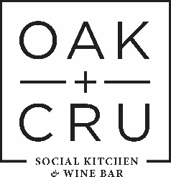

COVID-19 OPERATING SAFETY PLAN
&
SERVICE PROCEDURES

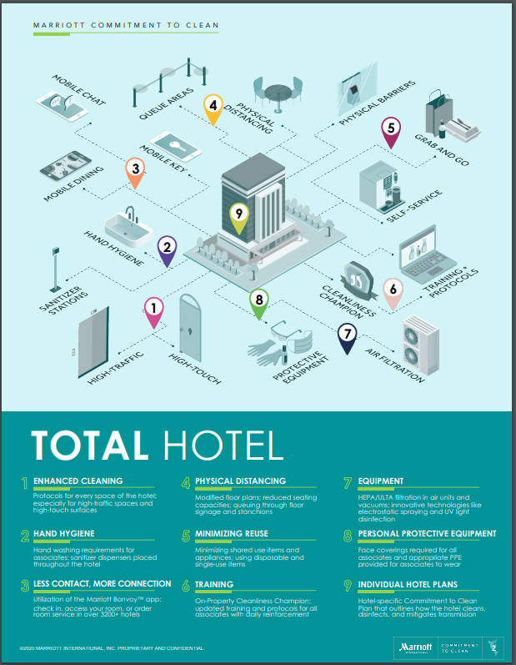

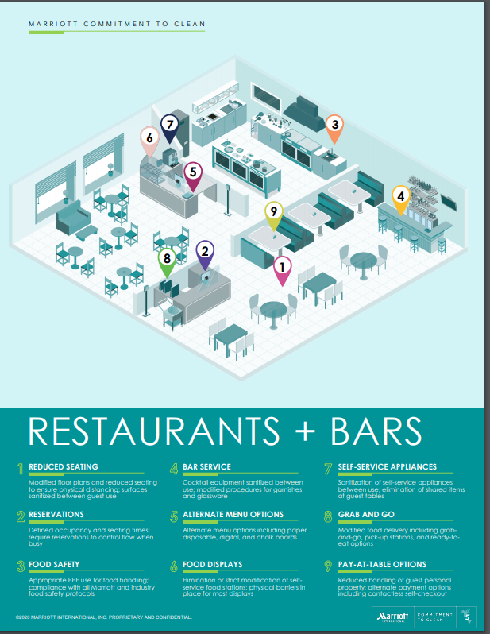

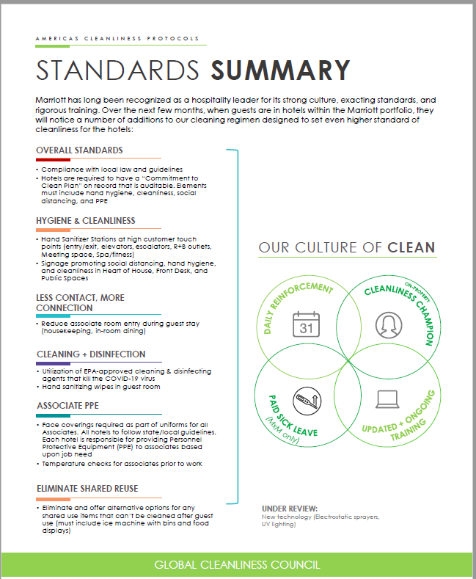

This safety plan includes detailed steps the restaurant and hotel are taking to address the following, based upon local requirements, hotel type, size, and other relevant factors:
- Associate hand hygiene (washing, sanitization, etc.) and coughing and sneezing etiquette
- Cleaning and sanitizing products, frequency and protocols throughout the hotel
- Associate PPE and screening processes: masks, gloves, temperature checks (required by Managed by Marriott (MxM) hotels)
- Social Distancing including how to address within F+B spaces
- Guest signage for cleanliness and social distancing communications
- Guest room entry (housekeeping, In-room dining, etc.)
- F+B and M+E execution to promote clean and safe events
- Process for contact tracing for guests who dine in Showcase including reservations and walk-ins

#1 Risk Assessment – OAK+CRU Social Kitchen
- Front of House and Back of House associates represent OAK+CRU at the hotel’s Joint Health and Safety meeting that meet monthly to review health and safety practices, incidents and safety evaluation.
- The occupancy in Showcase has been reduced to 174 seats ensuring that tables are spaced 2 meters apart. Any seating that does not allow 2 meters distancing a partition has been installed to protect associates and guests **See floor plan and posted occupancy signage.
- We schedule in teams for front of house and back of house to reduce the number of staff interacting with each other.
- We have identified the following high touch points and equipment that will be washed and/or sanitized on a frequent basis or after every use. **See cleaning checklists for FOH and BOH in this document and posted in the restaurant and kitchen.
Front of House - Every 2 hours for high touch surfaces
  - POS terminals
  - Credit card machines
  - Tables & Chairs
  - Service stations
  - Service trays
  - Bar top
  - Hostess station
  - Telephones
  - Bar and cocktail equipment
  - Pens, check presenters
  - Kitchen prep area and drawers
  - Service doors
  - Fridge doors
  - Coffee machine
  - Cappuccino machine
  - TV remotes
  - Draft taps
  - Plexiglas partitions
  - Front doors
  - Booster seats, high chairs
Back of House – Every 2 hours for high touch surfaces
- Counters
- Prep area
- Counters
- Prep area
- Kitchen utensils
- Cook surfaces
- Floors
- Door knobs
- Cooler doors
- Cooler handles
- Oven doors
- Plate ware (high temp dish logs taken 3 times daily)
- Glass ware (high temp dish logs taken 3 times daily)
- Stair hand rails
#2 Work Protocols
- Physical Distancing
    - Occupancy limit guests reduced
    - Reduced floor plan to accommodate 2 meter distancing
    - Staggered start times for associates with individual briefings
    - Plexiglas barriers installed anywhere 2 meter distancing is not possible
    - Marked flow of entrances and exits for staff and guests
    - Associates wear non-medical masks

- Installation of Physical Barriers
    - Installation of Plexiglas between booths
    - Daily cleaning protocol for Plexiglas are included in the daily cleaning checklist

- Cleaning and Sanitization Protocol
    - Refer to the Ecolab guidance document for Food Service “Resuming Hospitality Operations”
    - Assume recommended use for high risk/outbreak scenario including mulit-purpose cleaner and food contact sanitizer.
    - Refer to daily, weekly cleaning schedule.
- Handwashing
    - Every 2 hours or after guest interaction/serving or clearing dishes
    - Documentation posted on effective handwashing protolcol

#3 Code of Conduct and Policies for all associates
- No associates will come to work sick, specifically exhibiting any Covid-19 symptoms such as fever, chills, new or worsening cough, shortness of breath, sore throat, muscle or headache within the past 10 days
- Associates will self-isolate when directed by Public Health
- Associates who have arrived from outside Canada or who has had contact with a confirmed Covid-19 case must self-isolate for 14 days and monitor for symptoms
- Visitors are prohibited in the workplace
- First Aid attendants have been provided OFAA protocols for use during Covid pandemic
- Associates have signed off on training and service protocols
- Associates have training and strategies required to address the risk of violence that may arise as customers adapt to restrictions or modifications of the restaurant operations.
- Mandatory temperature check prior to starting work, associates with a temperature of 38 degrees Celsius or above will be sent home from work for a minimum of 72 hours clear unmediated fever
- Associates must be aware of and trained on details of plan and be able to communicate when asked
- All Associates are required to wear face coverings approved by the CDC (N95 masks, cloth coverings, etc.) while working (re-evaluated every 30 days). Each hotel will be responsible for providing PPE to associates based upon job need
- Mandatory hand washing when entering the restaurant and frequent washing throughout the shift
- Handwashing after clearing tables
- Use of clean service trays after use
- Adhere to best possible social distancing practices throughout service
- Immediately sanitize one use equipment after use (POS screen, credit card terminal)
- Follow guidance for one way use doors
- Report associates to a manager who is not following protocol
- Associates that feel ill at work must report symptoms to a manager and will be send home immediately
- Sick associates are asked to wash or sanitize their hands, wear a mask, be sent home immediately, self-isolate and consult the BC Covid-19 Self-Assessment Tool or call 811 for further guidance
- Associates who are severely ill should call 911
- Managers will ensure that all surfaces that have been in contact with ill associates are sanitized
- Notification and tracking of sick guests/associates

#4 Communication Plan and Training
Handwashing Protocol
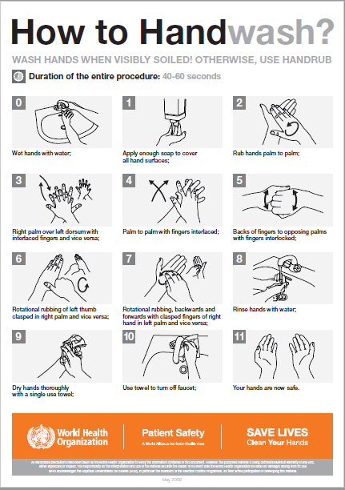
WHO – Steps to take off PPE
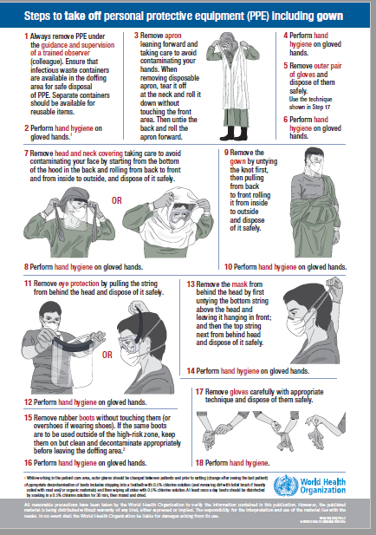
Front of House Cleaning Program
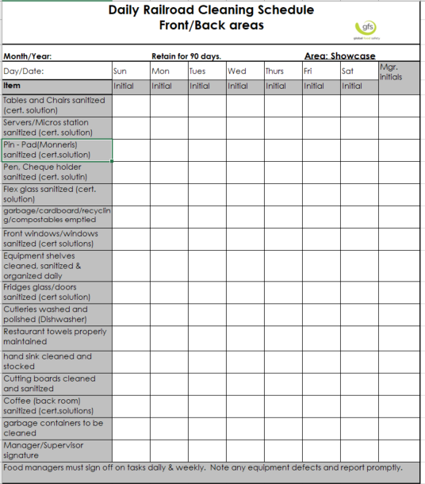

Bar Glassware Cleaning Protocol

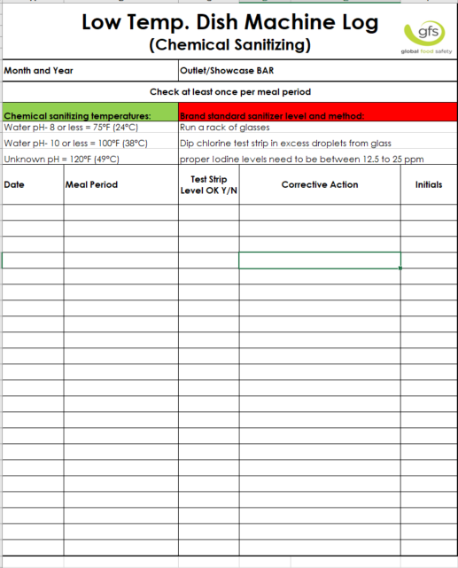

Server Safety Protocol
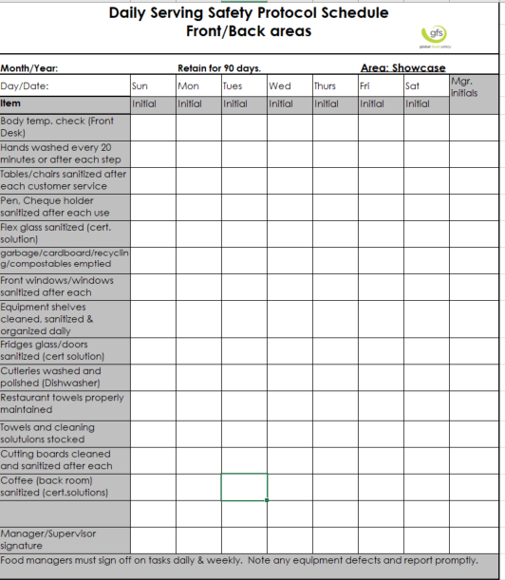
Guest Tracing Protocol – 1 member from each party will be required to give their name and contact information for the purposes of contacting them in the case of a Covid-19 case identified within the restaurant. Name, contact information, table number, number of people dining and time of day will be recorded.

Culinary Cleaning Protocol
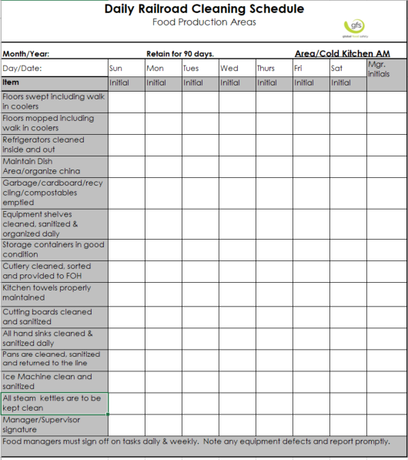

Kitchen Weekly Cleaning Checklist
